SECRETARÍA DE ESTADO DE

PRESUPUESTOS Y GASTOS

**2024**

DIRECCIÓN GENERAL DE COSTES PERSONAL

**RETRIBUCIONES DEL PERSONAL FUNCIONARIO**

***Real Decreto-ley 4/2024, de 26 de junio, por el que se prorrogan determinadas medidas para afrontar las consecuencias económicas y sociales derivadas de los conflictos en Ucrania y Oriente Próximo y se adoptan***

***medidas urgentes en materia fiscal, energética y social. (art.6)***

**A1**

**UN TRIENIO**

**A2**

**UN TRIENIO**

**B**

**C1**

**UN TRIENIO**

**C2**

**UN TRIENIO**

**Agrup. Profesional E**

**SUELDO**

1.326,90

**SUELDO**

1.147,35

**13.768,20**

**836,78**

**SUELDO**

1.002,94

**12.035,28**

**866,84**

**UN TRIENIO**

**SUELDO**

861,46

**SUELDO**

716,98

**8.603,76**

**710,44**

**710,44**

**SUELDO**

656,23

**UN TRIENIO**

**M E N S U A L**

51,07

**612,84**

**31,53**

**31,53**

41,65

**499,80**

**30,37**

**30,37**

36,54

**438,48**

**31,60**

**31,60**

31,53

**378,36**

**27,21**

**27,21**

21,46

**257,52**

**21,24**

**21,24**

16,16

**193,92**

**16,16**

**16,16**

**A N U A L (12 meses)**

**PAGA EXTRA JUNIO**

**1**

**5.922,80**

**10.337,52**

**7.874,76**

**656,23**

**656,23**

**8**

**8**

**18,82**

**18,82**

**744,56**

**PAGA EXTRA DICIEMBRE**

**T O T A L A N U A L**

**836,78**

**866,84**

**744,56**

**1**

**7.560,44**

**675,90**

**15.441,76**

**560,54**

**13.768,96**

**501,68**

**11.826,64**

**432,78**

**10.024,64**

**300,00**

**9.187,22**

**226,24**

**COMPLEMENTO DE DESTINO**

**TOTAL SUELDO Y COMPLEMENTO DE DESTINO (Sin Trienios)**

**NIVEL**

**MES**

**AÑO (*)**

**MES**

**AÑO**

**MES**

**AÑO**

**MES**

**AÑO**

**MES**

**AÑO**

**MES**

**AÑO**

**MES (**)**

**AÑO (**)**

***3***

***2***

***2***

***2***

***2***

***2***

***2***

***2***

***2***

***2***

***2***

***1***

***1***

***1***

***1***

***1***

***1***

***1***

***0***

***9***

***8***

***7***

***6***

***5***

***4***

***3***

***2***

***1***

***0***

***9***

***8***

***7***

***6***

***5***

***4***

***3***

1.159,06

1.039,61

995,93

952,17

835,38

741,15

697,43

653,76

610,00

566,36

526,09

499,24

472,37

445,50

418,69

391,78

364,97

338,07

311,19

284,31

257,49

244,08

230,61

217,19

203,76

190,32

170,18

150,08

129,94

109,81

**16.226,84**

2.485,96

2.366,51

2.322,83

2.279,07

2.162,28

2.068,05

2.024,33

1.980,66

1.936,90

**33.787,28**

**32.114,98**

**31.503,46**

**30.890,82**

**29.255,76**

**27.936,54**

**27.324,46**

**26.713,08**

**26.100,44**

**25.489,48**

**24.925,70**

**24.549,80**

**24.173,62**

**23.797,44**

**23.422,10**

**23.045,36**

**22.670,02**

**22.293,42**

**21.917,10**

**21.540,78**

**21.165,30**

**20.977,56**

**20.788,98**

**20.601,10**

**20.413,08**

**20.224,92**

**19.942,96**

**19.661,56**

**19.379,60**

**19.097,78**

2.306,41

**31.668,60**

**29.996,30**

**29.384,78**

**28.772,14**

**27.137,08**

**25.817,86**

**25.205,78**

**24.594,40**

**23.981,76**

**23.370,80**

**22.807,02**

**22.431,12**

**22.054,94**

**21.678,76**

**21.303,42**

**20.926,68**

**20.551,34**

**20.174,74**

**19.798,42**

**19.422,10**

**19.046,62**

**18.858,88**

**18.670,30**

**18.482,42**

**18.294,40**

**18.106,24**

**17.824,28**

**17.542,88**

**17.260,92**

**16.979,10**

2.162,00

2.042,55

1.998,87

1.955,11

**29.995,80**

**28.323,50**

**27.711,98**

**27.099,34**

**25.464,28**

**24.145,06**

**23.532,98**

**22.921,60**

**22.308,96**

**21.698,00**

**21.134,22**

**20.758,32**

**20.382,14**

**20.005,96**

**19.630,62**

**19.253,88**

**18.878,54**

**18.501,94**

**18.125,62**

**17.749,30**

**17.373,82**

**17.186,08**

**16.997,50**

**16.809,62**

**16.621,60**

**16.433,44**

**16.151,48**

**15.870,08**

**15.588,12**

**15.306,30**

2.020,52

1.901,07

1.857,39

1.813,63

1.696,84

1.602,61

1.558,89

1.515,22

1.471,46

1.427,82

1.387,55

1.360,70

1.333,83

1.306,96

1.280,15

1.253,24

1.226,43

1.199,53

1.172,65

1.145,77

1.118,95

1.105,54

1.092,07

1.078,65

1.065,22

1.051,78

1.031,64

1.011,54

991,40

**28.053,48**

**26.381,18**

**25.769,66**

**25.157,02**

**23.521,96**

**22.202,74**

**21.590,66**

**20.979,28**

**20.366,64**

**19.755,68**

**19.191,90**

**18.816,00**

**18.439,82**

**18.063,64**

**17.688,30**

**17.311,56**

**16.936,22**

**16.559,62**

**16.183,30**

**15.806,98**

**15.431,50**

**15.243,76**

**15.055,18**

**14.867,30**

**14.679,28**

**14.491,12**

**14.209,16**

**13.927,76**

**13.645,80**

**13.363,98**

1.876,04

1.756,59

1.712,91

1.669,15

1.552,36

1.458,13

1.414,41

1.370,74

1.326,98

1.283,34

1.243,07

1.216,22

1.189,35

1.162,48

1.135,67

1.108,76

1.081,95

1.055,05

1.028,17

1.001,29

974,47

**26.251,48**

**24.579,18**

**23.967,66**

**23.355,02**

**21.719,96**

**20.400,74**

**19.788,66**

**19.177,28**

**18.564,64**

**17.953,68**

**17.389,90**

**17.014,00**

**16.637,82**

**16.261,64**

**15.886,30**

**15.509,56**

**15.134,22**

**14.757,62**

**14.381,30**

**14.004,98**

**13.629,50**

**13.441,76**

**13.253,18**

**13.065,30**

**12.877,28**

**12.689,12**

**12.407,16**

**12.125,76**

**11.843,80**

**11.561,98**

1.864,06

1.739,60

1.694,09

1.648,52

1.526,77

1.428,60

1.383,03

1.337,51

1.291,90

1.246,44

1.204,49

1.176,49

1.148,47

1.120,47

1.092,52

1.064,53

1.036,55

1.008,53

980,52

952,52

924,58

910,59

896,55

882,57

868,56

854,57

833,58

**26.096,84**

**24.354,40**

**23.717,26**

**23.079,28**

**21.374,78**

**20.000,40**

**19.362,42**

**18.725,14**

**18.086,60**

**17.450,16**

**16.862,86**

**16.470,86**

**16.078,58**

**15.686,58**

**15.295,28**

**14.903,42**

**14.511,70**

**14.119,42**

**13.727,28**

**13.335,28**

**12.944,12**

**12.748,26**

**12.551,70**

**12.355,98**

**12.159,84**

**11.963,98**

**11.670,12**

**11.377,24**

**11.083,10**

**10.789,10**

**14.554,54**

2.186,96

2.143,28

2.099,52

**13.943,02**

**13.330,38**

**11.695,32**

**10.376,10**

**9.764,02**

**9.152,64**

**8.540,00**

**7.929,04**

**7.365,26**

**6.989,36**

**6.613,18**

**6.237,00**

**5.861,66**

**5.484,92**

**5.109,58**

**4.732,98**

**4.356,66**

**3.980,34**

**3.604,86**

**3.417,12**

**3.228,54**

**3.040,66**

**2.852,64**

**2.664,48**

**2.382,52**

1.982,73

1.888,50

1.844,78

1.801,11

1.757,35

1.713,71

1.673,44

1.646,59

1.619,72

1.592,85

1.566,04

1.539,13

1.512,32

1.485,42

1.458,54

1.431,66

1.404,84

1.391,43

1.377,96

1.364,54

1.351,11

1.337,67

1.317,53

1.297,43

1.277,29

1.257,16

1.838,32

1.744,09

1.700,37

1.656,70

1.612,94

1.893,26

1.852,99

1.826,14

1.799,27

1.772,40

1.745,59

1.718,68

1.691,87

1.664,97

1.638,09

1.611,21

1.584,39

1.570,98

1.557,51

1.544,09

1.530,66

1.517,22

1.497,08

1.476,98

1.456,84

1.436,71

1.569,30

1.529,03

1.502,18

1.475,31

1.448,44

1.421,63

1.394,72

1.367,91

1.341,01

1.314,13

1.287,25

1.260,43

1.247,02

1.233,55

1.220,13

1.206,70

1.193,26

1.173,12

1.153,02

1.132,88

1.112,75

***1***

***1***

***1***

***2***

***1***

***0***

***9***

961,06

947,59

934,17

920,74

907,30

887,16

867,06

846,92

***8***

***7***

***6***

***5***

***4***

***3***

***2***

***1***

**2.101,12**

812,66

791,65

770,65

**1.819,16**

**1.537,34**

971,27

826,79

***(*) Incluye 14 percepciones***

***(**) Se mantienen a título personal las cuantías del C.D. del grupo E/Agrupaciones profesionales del EBEP (Art. 23 Uno G) de la LPGE 2023). No obstante, el C.D. del personal de este grupo que ingresó a partir de 31/5/2010 es el mismo***

***que figura en la primera columna***

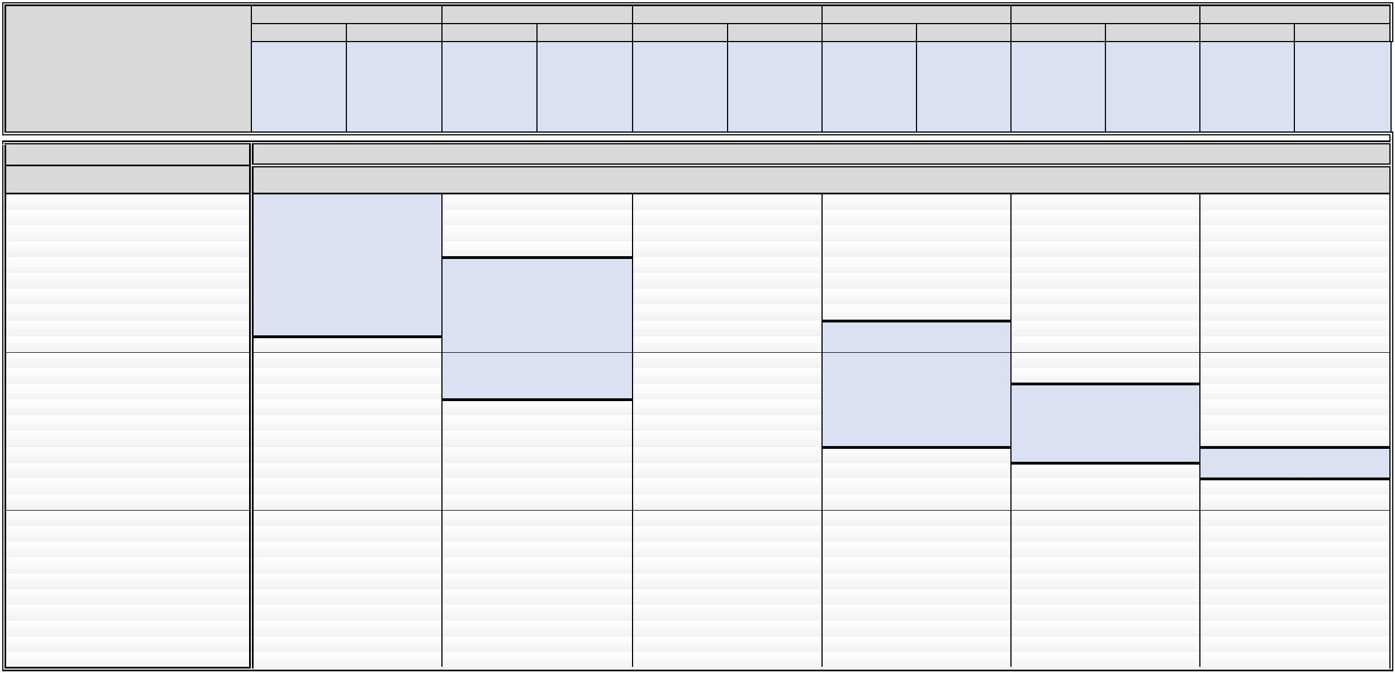

**CUANTÍAS DE LOS COMPLEMENTOS ESPECÍFICOS 2024**

**Cuantía paga**

**adicional**

**Cuantía anual**

**Cuantía paga**

**adicional**

**Cuantía anual**

**Cuantía mensual**

**Cuantía mensual**

2

2

2

2

2

1

1

1

1

1

1

1

1

1

1

1

1

1

1

1

1

1

1

1

1

1

1

1

1

.456,35

.380,95

.230,17

.079,43

.003,97

.903,45

.802,93

.677,29

.569,93

.526,87

.494,52

.378,22

.343,72

.243,24

.241,76

.233,65

.167,81

.141,13

.139,95

.120,99

.119,08

.111,15

.071,46

.037,35

.020,78

.007,32

.005,81

.004,17

.003,76

97,57

56,01

44,84

37,56

16,68

04,22

03,01

95,87

80,71

78,55

52,83

34,50

17,98

66,62

63,29

56,73

44,44

37,15

98,35

93,08

86,41

72,13

63,32

59,58

58,02

54,08

2.456,35

2.380,95

2.230,17

2.079,43

2.003,97

1.903,45

1.802,93

1.677,29

1.569,93

1.526,87

1.494,52

1.378,22

1.343,72

1.243,24

1.241,76

1.233,65

1.167,81

1.141,13

1.139,95

1.120,99

1.119,08

1.111,15

1.071,46

1.037,35

1.020,78

1.007,32

1.005,81

1.004,17

1.003,76

997,57

956,01

944,84

937,56

916,68

904,22

903,01

895,87

880,71

878,55

852,83

834,50

817,98

766,62

763,29

756,73

744,44

34.388,90

33.333,30

31.222,38

29.112,02

28.055,58

26.648,30

25.241,02

23.482,06

21.979,02

21.376,18

20.923,28

19.295,08

18.812,08

17.405,36

17.384,64

17.271,10

16.349,34

15.975,82

15.959,30

15.693,86

15.667,12

15.556,10

15.000,44

14.522,90

14.290,92

14.102,48

14.081,34

14.058,38

14.052,64

13.965,98

13.384,14

13.227,76

13.125,84

12.833,52

12.659,08

12.642,14

12.542,18

12.329,94

12.299,70

11.939,62

11.683,00

11.451,72

10.732,68

10.686,06

10.594,22

10.422,16

10.320,10

9.776,90

648,31

647,54

645,28

643,98

620,77

603,38

598,61

597,75

582,98

576,10

568,73

554,00

552,00

551,69

518,67

509,87

509,86

498,42

493,00

472,55

471,84

471,41

467,31

443,73

440,74

431,51

416,48

408,52

397,38

395,79

395,56

391,89

390,85

388,27

388,08

382,87

379,19

378,58

377,00

372,74

372,67

356,32

355,85

355,51

350,82

349,98

334,40

330,17

310,04

309,17

308,84

306,69

301,65

288,60

266,38

648,31

647,54

645,28

643,98

620,77

603,38

598,61

597,75

582,98

576,10

568,73

554,00

552,00

551,69

518,67

509,87

509,86

498,42

493,00

472,55

471,84

471,41

467,31

443,73

440,74

431,51

416,48

408,52

397,38

395,79

395,56

391,89

390,85

388,27

388,08

382,87

379,19

378,58

377,00

372,74

372,67

356,32

355,85

355,51

350,82

349,98

334,40

330,17

310,04

309,17

308,84

306,69

301,65

288,60

266,38

9.076,34

9.065,56

9.033,92

9.015,72

8.690,78

8.447,32

8.380,54

8.368,50

8.161,72

8.065,40

7.962,22

7.756,00

7.728,00

7.723,66

7.261,38

7.138,18

7.138,04

6.977,88

6.902,00

6.615,70

6.605,76

6.599,74

6.542,34

6.212,22

6.170,36

6.041,14

5.830,72

5.719,28

5.563,32

5.541,06

5.537,84

5.486,46

5.471,90

5.435,78

5.433,12

5.360,18

5.308,66

5.300,12

5.278,00

5.218,36

5.217,38

4.988,48

4.981,90

4.977,14

4.911,48

4.899,72

4.681,60

4.622,38

4.340,56

4.328,38

4.323,76

4.293,66

4.223,10

4.040,40

3.729,32

9

9

9

9

9

9

9

8

8

8

8

8

8

7

7

7

7

7

6

6

6

6

6

6

6

6

737,15

698,35

693,08

686,41

672,13

663,32

659,58

658,02

9.703,12

9.609,74

9.409,82

9.286,48

9.234,12

9.212,28

9.157,12

654,08

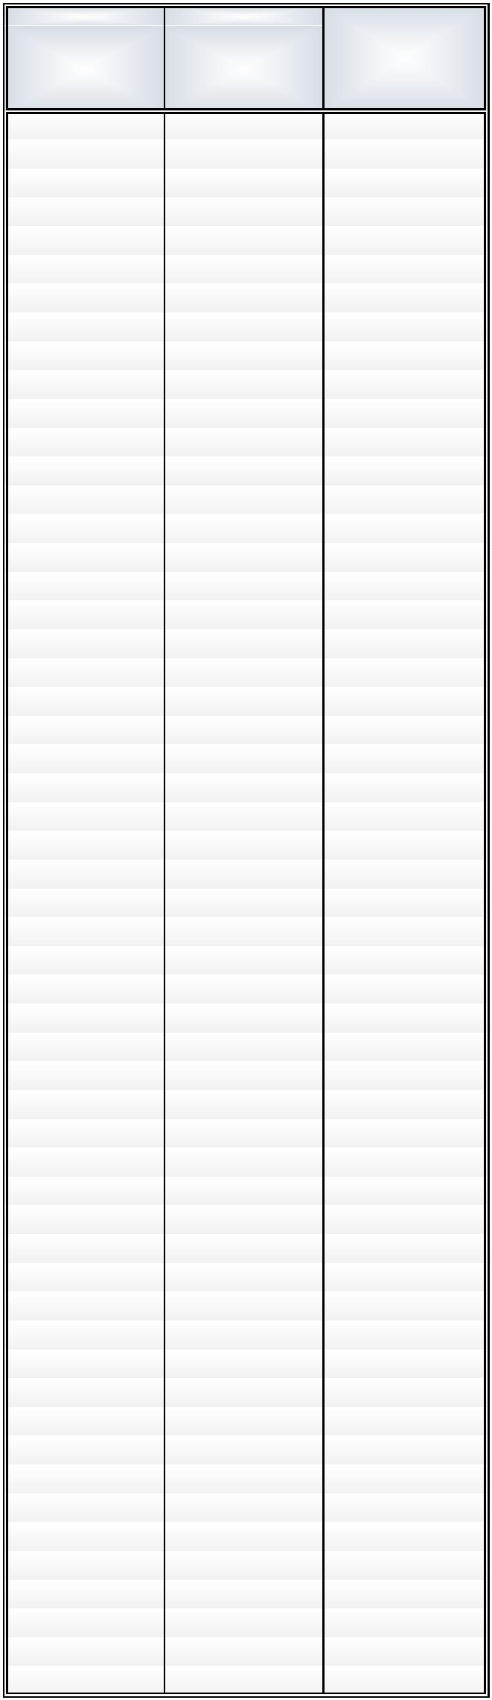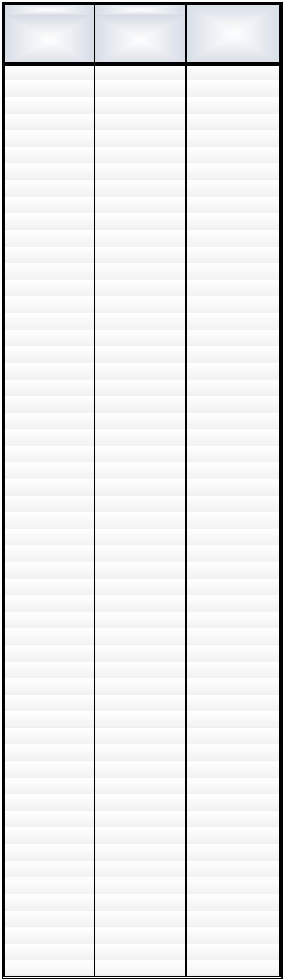

**CUANTÍAS COMPLEMENTOS ESPECÍFICOS 2024**

**CUANTÍA**

**CUANTÍA**

**CUANTÍA**

**CUANTÍA**

**MENSUAL**

**ANUAL**

**MENSUAL**

**ANUAL**

**MENSUAL**

**ANUAL**

**MENSUAL**

**ANUAL**

2.456,35

2.380,95

2.230,17

2.079,43

2.003,97

1.903,45

1.802,93

1.677,29

1.569,93

1.526,87

1.494,52

1.378,22

1.343,72

1.243,24

1.241,76

1.233,65

1.167,81

1.141,13

1.139,95

1.120,99

1.119,08

1.111,15

1.071,46

1.037,35

1.020,78

1.007,32

1.005,81

1.004,17

34.388,90

33.333,30

31.222,38

29.112,02

28.055,58

26.648,30

25.241,02

23.482,06

21.979,02

21.376,18

20.923,28

19.295,08

18.812,08

17.405,36

17.384,64

17.271,10

16.349,34

15.975,82

15.959,30

15.693,86

15.667,12

15.556,10

15.000,44

14.522,90

14.290,92

14.102,48

14.081,34

14.058,38

1.003,76

997,57

956,01

944,84

937,56

916,68

904,22

903,01

895,87

880,71

878,55

852,83

834,50

817,98

766,62

763,29

756,73

744,44

737,15

698,35

693,08

686,41

672,13

663,32

659,58

658,02

654,08

648,31

14.052,64

13.965,98

13.384,14

13.227,76

13.125,84

12.833,52

12.659,08

12.642,14

12.542,18

12.329,94

12.299,70

11.939,62

11.683,00

11.451,72

10.732,68

10.686,06

10.594,22

10.422,16

10.320,10

9.776,90

9.703,12

9.609,74

9.409,82

9.286,48

9.234,12

9.212,28

9.157,12

9.076,34

647,54

645,28

643,98

620,77

603,38

598,61

597,75

582,98

576,10

568,73

554,00

552,00

551,69

518,67

509,87

509,86

498,42

493,00

472,55

471,84

471,41

467,31

443,73

440,74

431,51

416,48

408,52

397,38

9.065,56

9.033,92

9.015,72

8.690,78

8.447,32

8.380,54

8.368,50

8.161,72

8.065,40

7.962,22

7.756,00

7.728,00

7.723,66

7.261,38

7.138,18

7.138,04

6.977,88

6.902,00

6.615,70

6.605,76

6.599,74

6.542,34

6.212,22

6.170,36

6.041,14

5.830,72

5.719,28

5.563,32

395,79

395,56

391,89

390,85

388,27

388,08

382,87

379,19

378,58

377,00

372,74

372,67

356,32

355,85

355,51

350,82

349,98

334,40

330,17

310,04

309,17

308,84

306,69

301,65

288,60

266,38

5.541,06

5.537,84

5.486,46

5.471,90

5.435,78

5.433,12

5.360,18

5.308,66

5.300,12

5.278,00

5.218,36

5.217,38

4.988,48

4.981,90

4.977,14

4.911,48

4.899,72

4.681,60

4.622,38

4.340,56

4.328,38

4.323,76

4.293,66

4.223,10

4.040,40

3.729,32

