ꢀ ꢀ



ꢀꢀ

ÈUHDꢀGHꢀ\*RELHUQRꢀGHꢀ(FRQRPtDꢀ\ꢀ+DFLHQGDꢁꢀꢀ 3UHVLGHQFLDꢀ\ꢀ&XOWXUDꢀ

,QWHUYHQFLyQꢀ\*HQHUDOꢀ &)3ꢀꢁ(67$%ꢁ/,4ꢁꢂꢃꢂꢄꢁ

,\*5ꢁꢁꢁ3\*$ꢀ ꢀ

ꢀ

,1)250(ꢀ'(ꢀ&21752/ꢀ),1$1&,(52ꢀ3(50$1(17(ꢀ

ꢀ ꢀ ꢀ

(QꢀꢀFXPSOLPLHQWRꢀꢀGHꢀꢀORꢀꢀGLVSXHVWRꢀꢀHQꢀꢀODꢀ/H\ꢀ2UJiQLFDꢀꢁꢂꢁꢃꢄꢁꢅꢀGHꢀꢁꢆꢀGHꢀDEULOꢅꢀGHꢀ(VWDELOLGDGꢀ 3UHVXSXHVWDULDꢀ\ꢀ6RVWHQLELOLGDGꢀ)LQDQFLHUDꢀ\ꢀHQꢀHOꢀꢀDUWtFXORꢀꢀꢄꢇꢈꢁꢀꢀGHOꢀꢀ5HDOꢀꢀ'HFUHWRꢀꢄꢉꢇꢊꢂꢁꢃꢃꢆꢅꢀGHꢀꢁꢀGHꢀ QRYLHPEUHꢅꢀSRUꢀHOꢀTXHꢀVHꢀDSUXHEDꢀHOꢀ5HJODPHQWRꢀGHꢀGHVDUUROORꢀGHꢀODꢀ/H\ꢀGHꢀ(VWDELOLGDGꢀ3UHVXSXHVWDULDꢅꢀ HQꢀ VXꢀ DSOLFDFLyQꢀ Dꢀ ODVꢀ HQWLGDGHVꢀ ORFDOHVꢅꢀ ODꢀ ,QWHUYHQFLyQꢀ \*HQHUDOꢀ GHOꢀ ([FPRꢈꢀ $\XQWDPLHQWRꢀ GHꢀ /DVꢀ 3DOPDVꢀGHꢀ\*UDQꢀ&DQDULDꢀHPLWHꢀHOꢀVLJXLHQWHꢀ

ꢀ ꢀ

ꢀ

,1)250(ꢀꢀ

ꢀ ꢀ

5HODWLYRꢀ DOꢀ DQiOLVLVꢀ GHꢀ ODꢀ (VWDELOLGDGꢅꢀ GHꢀ ODꢀ 5HJODꢀ GHꢀ \*DVWRꢀ \ꢀ GHOꢀ QLYHOꢀ GHꢀ 'HXGDꢀ ꢀ HQꢀ ODꢀꢀ /LTXLGDFLyQꢀꢋVXVSHQGLGRVꢌꢀGHꢀ3UHVXSXHVWRꢀ\*HQHUDOꢀSDUDꢀꢀHOꢀꢀHMHUFLFLRꢀꢀꢁꢃꢁꢄꢈꢀ

ꢀ ꢀ

/(\*,6/$&,Ï1ꢀ$3/,&$%/(ꢀ

ꢀꢀ

aꢁ /H\ꢀ2UJiQLFDꢀꢁꢂꢁꢃꢄꢁꢅꢀGHꢀꢁꢆꢀGHꢀDEULOꢅꢀGHꢀ(VWDELOLGDGꢀ3UHVXSXHVWDULDꢀ\ꢀ6RVWHQLELOLGDGꢀ)LQDQFLHUDꢀ

ꢋ/2(36)ꢌꢀ

aꢁ 5HDOꢀ'HFUHWRꢀꢄꢉꢇꢊꢂꢁꢃꢃꢆꢅꢀGHꢀꢁꢀGHꢀQRYLHPEUHꢅꢀSRUꢀHOꢀTXHꢀVHꢀDSUXHEDꢀHOꢀUHJODPHQWRꢀGHꢀꢀꢀGHVDUUROORꢀꢀꢀ

GHꢀꢀꢀGLFKDꢀꢀꢀ/H\ꢅꢀꢀꢀHQꢀ VXꢀꢀꢀDSOLFDFLyQꢀꢀꢀDꢀꢀꢀODVꢀꢀꢀHQWLGDGHVꢀꢀꢀORFDOHVꢀꢋ5(\*/$0(172ꢌꢈꢀ

aꢁ 5HDOꢀ'HFUHWRꢀ/HJLVODWLYRꢀꢁꢂꢁꢃꢃꢉꢅꢀGHꢀꢍꢀGHꢀPDU]Rꢅꢀꢋ75/5+/ꢌꢀTXHꢀDSUXHEDꢀHOꢀWH[WRꢀUHIXQGLGRꢀGHꢀ ODꢀ /H\ꢀ 5HJXODGRUDꢀ GHꢀ ODVꢀ +DFLHQGDVꢀ /RFDOHVꢅꢀ HQꢀ UHODFLyQꢀ DOꢀ 3ULQFLSLRꢀ GHꢀ (VWDELOLGDGꢀ 3UHVXSXHVWDULDꢈꢀ

aꢁ 0DQXDOꢀꢀGHꢀꢀFiOFXORꢀꢀGHOꢀꢀ'pILFLWꢀꢀHQꢀꢀ&RQWDELOLGDGꢀꢀ1DFLRQDOꢀꢀDGDSWDGRꢀꢀDꢀꢀODVꢀ&RUSRUDFLRQHVꢀꢀ

/RFDOHVꢅꢀꢀSXEOLFDGRꢀꢀSRUꢀꢀODꢀꢀ,\*$(ꢅꢀꢀ0LQLVWHULRꢀꢀGHꢀꢀ(FRQRPtDꢀꢀ\ꢀ+DFLHQGDꢈꢀ

aꢁ \*XtDꢀ SDUDꢀ ODꢀ GHWHUPLQDFLyQꢀ GHꢀ ODꢀ 5HJODꢀ GHꢀ \*DVWRꢀ GHOꢀ DUWtFXORꢀ ꢄꢁꢀ GHꢀ ODꢀ /2(36)ꢀ SDUDꢀ

FRUSRUDFLRQHVꢀORFDOHVꢅꢀꢊꢀHGLFLyQꢈꢀ,\*$(ꢀꢋQRYLHPEUHꢀꢁꢃꢄꢉꢌꢈꢀ

aꢁ 0DQXDOꢀGHOꢀ6(&ꢀꢀVREUHꢀHOꢀ'pILFLWꢀ3~EOLFRꢀ\ꢀODꢀ'HXGDꢀ3~EOLFDꢅꢀSXEOLFDGRꢀSRUꢀ(XURVWDWꢈꢀ

aꢁ 2UGHQꢀ+$3ꢂꢁꢄꢃꢍꢂꢁꢃꢄꢁꢅꢀGHꢀꢄꢀGHꢀRFWXEUHꢅꢀSRUꢀODꢀTXHꢀVHꢀGHVDUUROODQꢀODVꢀREOLJDFLRQHVꢀGHꢀVXPLQLVWURꢀ

GHꢀLQIRUPDFLyQꢀSUHYLVWDVꢀHQꢀODꢀ/2(36)ꢈꢀ

aꢁ 5HDOꢀ 'HFUHWRꢀ ꢉꢁꢉꢂꢁꢃꢄꢆꢅꢀ GHꢀ ꢁꢎꢀ GHꢀ DEULOꢅꢀ SRUꢀ HOꢀ TXHꢀ VHꢀ UHJXODꢀ HOꢀ UpJLPHQꢀ MXUtGLFRꢀ GHOꢀ FRQWUROꢀ

LQWHUQRꢀHQꢀODVꢀHQWLGDGHVꢀGHOꢀ6HFWRUꢀ3~EOLFRꢀ/RFDOꢈꢀ

aꢁ $FXHUGRꢀGHOꢀ&RQVHMRꢀGHꢀ0LQLVWURVꢅꢀGHꢀIHFKDꢀꢄꢄꢂꢃꢁꢂꢁꢃꢁꢃꢅꢀSRUꢀHOꢀTXHꢀVHꢀDFWXDOL]DQꢀORVꢀREMHWLYRVꢀ GHꢀHVWDELOLGDGꢀSUHVXSXHVWDULDꢅꢀGHXGDꢀS~EOLFDꢀ\ꢀYDULDFLyQꢀGHOꢀJDVWRꢀFRPSXWDEOHꢀSDUDꢀHOꢀFRQMXQWRꢀ GHꢀ$$33ꢀ\ꢀVXVꢀVXEVHFWRUHVꢈꢀꢀ

ꢀ

ꢀꢀꢀ

184

ꢀꢀ



ꢀ

ꢀꢀ

ÈUHDꢀGHꢀ\*RELHUQRꢀGHꢀ(FRQRPtDꢀ\ꢀ+DFLHQGDꢁꢀ3UHVLGHQFLDꢀ\ꢀ&XOWXUDꢀꢀ

,17(59(1&,21ꢀ\*(1(5$/ꢀ&)3ꢂꢀ(67$%ꢀ/,4ꢀ

3\*$ꢀꢀ

ꢀꢀꢀ ꢀ

3RUꢀDFXHUGRꢀGHOꢀ&RQVHMRꢀGHꢀ0LQLVWURVꢅꢀGHꢀꢄꢄꢀGHꢀIHEUHURꢀGHꢀꢁꢃꢁꢃꢅꢀVHꢀILMDURQꢀORVꢀREMHWLYRVꢀ GHꢀHVWDELOLGDGꢀSUHVXSXHVWDULDꢅꢀGHXGDꢀS~EOLFDꢀ\ꢀODꢀWDVDꢀGHꢀYDULDFLyQꢀDꢀHIHFWRVꢀGHꢀODꢀUHJODꢀGHꢀJDVWRꢀ SDUDꢀHOꢀWULHQLRꢀꢁꢃꢁꢄꢏꢁꢃꢁꢊꢀSDUDꢀHOꢀFRQMXQWRꢀGHꢀ$GPLQLVWUDFLRQHVꢀ3~EOLFDVꢀ\ꢅꢀSDUDꢀFDGDꢀXQRꢀGHꢀ VXVꢀVXEVHFWRUHVꢅꢀGHꢀFRQIRUPLGDGꢀFRQꢀORVꢀWpUPLQRVꢀSUHYLVWRVꢀHQꢀODꢀ/H\ꢀ2UJiQLFDꢀGHꢀ(VWDELOLGDGꢀ3UHVXSXHVWDULDꢀ\ꢀ6RVWHQLELOLGDGꢀ)LQDQFLHUDꢈꢀ1RꢀREVWDQWHꢅꢀSDUDꢀHOꢀHMHUFLFLRꢀꢁꢃꢁꢄꢅꢀODꢀVXVSHQVLyQꢀGHꢀORVꢀREMHWLYRVꢀGHꢀHVWDELOLGDGꢀSUHVXSXHVWDULDꢀ\ꢀGHXGDꢀS~EOLFDꢀIXHꢀꢀUDWLILFDGDꢀSRUꢀHOꢀ3OHQRꢀGHOꢀ&RQJUHVRꢀ GHꢀ ORVꢀ 'LSXWDGRVꢀ HOꢀ GtDꢀ ꢁꢃꢀ GHꢀ RFWXEUHꢀ GHꢀ ꢁꢃꢁꢃꢅꢀ GHꢀ DFXHUGRꢀ FRQꢀ HOꢀ SURFHGLPLHQWRꢀSUHYLVWRꢀHQꢀHOꢀDUWtFXORꢀꢄꢊꢍꢈꢉꢀGHꢀODꢀ&RQVWLWXFLyQꢅꢀDVtꢀFRPRꢀHQꢀHOꢀDUWtFXORꢀꢄꢄꢈꢊꢀGHꢀODꢀ/H\ꢀ2UJiQLFDꢀꢁꢂꢁꢃꢄꢁꢅꢀGHꢀꢁꢆꢀGHꢀDEULOꢅꢀGHꢀ(VWDELOLGDGꢀ3UHVXSXHVWDULDꢀ\ꢀ6RVWHQLELOLGDGꢀ)LQDQFLHUDꢅꢀDSUHFLiQGRVHꢀODꢀFRQFXUUHQFLDꢀGHꢀXQDꢀVLWXDFLyQꢀGHꢀHPHUJHQFLDꢀH[WUDRUGLQDULDꢈꢀ

ꢀꢀ

35,0(52ꢁꢀ &/$6,),&$&,Ï1ꢀ '(ꢀ /$6ꢀ 81,'$'(6ꢀ ,167,78&,21$/(6ꢀ 48(ꢀ ,17(\*5$1ꢀ(/ꢀ6(&725ꢀ3Ò%/,&2ꢀ/2&$/ꢀ

ꢀ

/Dꢀ FODVLILFDFLyQꢀ UHDOL]DGDꢀ SRUꢀ ODꢀ ,QWHUYHQFLyQꢀ \*HQHUDOꢀ GHOꢀ (VWDGRꢀ GHꢀ ORVꢀ $JHQWHVꢀ Rꢀ8QLGDGHVꢀTXHꢀLQWHJUDQꢀHOꢀVHFWRUꢀS~EOLFRꢀORFDOꢀGHꢀ/DVꢀ3DOPDVꢀGHꢀ\*UDQꢀ&DQDULDꢅꢀDꢀORVꢀHIHFWRVꢀGHꢀVXꢀLQFOXVLyQꢀHQꢀODVꢀFDWHJRUtDVꢀSUHYLVWDVꢀHQꢀHOꢀDUWtFXORꢀꢁꢈꢄꢀRꢀHQꢀHOꢀDUWtFXORꢀꢁꢈꢁꢀGHOꢀODꢀ/2(36)ꢀHVꢀODꢀVLJXLHQWHꢐꢀ

ꢄꢈꢏꢀ6HFWRUꢀ$GPLQLVWUDFLRQHVꢀ3~EOLFDVꢀꢋDUWtFXORꢀꢁꢈꢄꢌꢐꢀ

aꢁ $\XQWDPLHQWRꢀGHꢀ/DVꢀ3DOPDVꢀGHꢀ\*UDQꢀ&DQDULDꢀ

aꢁ ,QVWLWXWRꢀ0XQLFLSDOꢀGHꢀ'HSRUWHVꢀꢋ,0'ꢌꢀ

aꢁ ,QVWLWXWRꢀ0XQLFLSDOꢀꢀSDUDꢀHOꢀꢀ(PSOHRꢀ\ꢀ)RUPDFLyQꢀꢋ,0()ꢌꢀ

aꢁ ꢀ$JHQFLDꢀ/RFDOꢀ\*HVWRUDꢀGHꢀODꢀ(QHUJtDꢀꢋ$/\*(ꢌꢀ

aꢁ 6RFLHGDGꢀ 0XQLFLSDOꢀ GHꢀ \*HVWLyQꢀ 8UEDQtVWLFDꢀ GHꢀ /DVꢀ 3DOPDVꢀ GHꢀ \*UDQꢀ &DQDULDꢀ

ꢋ\*(856$ꢅꢀ6ꢈ$ꢈꢌꢀ

aꢁ ꢀ3URPRFLyQꢀGHꢀODꢀ&LXGDGꢀGHꢀ/DVꢀ3DOPDVꢀGHꢀ\*UDQꢀ&DQDULDꢈꢀ

aꢁ &RQVRUFLRꢀ0XVHRꢀGHꢀ1pVWRUꢀ

aꢁ )XQGDFLyQꢀ&DQDULDꢀ$XGLWRULRꢀ\ꢀ7HDWURꢀGHꢀ/DVꢀ3DOPDVꢀGHꢀ\*UDQꢀ&DQDULDꢈꢀ

aꢁꢀꢀ+RWHOꢀ6DQWDꢀ&DWDOLQDꢀ6ꢈ$ꢈꢀ

ꢁꢈꢏꢀ5HVWRꢀGHꢀ(QWHVꢀ3~EOLFRVꢀꢋDUWtFXORꢀꢁꢈꢁꢌꢐꢀ

&803/,0,(172ꢀ2%- ꢀ(67$%,/,'$'ꢀꢏ5(\*/$ꢀ'(ꢀ\*$672ꢀ/,4ꢀꢁꢃꢁꢄꢀ

185

ꢀꢀ



ꢀ

ꢀꢀ

ÈUHDꢀGHꢀ\*RELHUQRꢀGHꢀ(FRQRPtDꢀ\ꢀ+DFLHQGDꢁꢀ3UHVLGHQFLDꢀ\ꢀ&XOWXUDꢀꢀ

,17(59(1&,21ꢀ\*(1(5$/ꢀ&)3ꢂꢀ(67$%ꢀ/,4ꢀ

3\*$ꢀꢀ

ꢀ

aꢁ ꢀꢀ6RFLHGDGꢀ 0XQLFLSDOꢀ GHꢀ $SDUFDPLHQWRVꢀ GHꢀ /DVꢀ 3DOPDVꢀ GHꢀ \*UDQꢀ &DQDULDꢀ

ꢋ6$\*8/3$ꢀ6ꢈ$ꢌꢈꢀ

aꢁ \*XDJXDVꢀ0XQLFLSDOHVꢀ6ꢈ$ꢈꢀ

$Oꢀ GtDꢀ GHꢀ ODꢀ IHFKDꢅꢀ HOꢀ &RQVRUFLRꢀ 0XVHRꢀ GHꢀ 1pVWRUꢀ QRꢀ KDꢀ UHPLWLGRꢀ ODꢀ SURSXHVWDꢀ GHꢀ OLTXLGDFLyQꢀ Dꢀ ODꢀ ,QWHUYHQFLyQꢀ \*HQHUDOꢈꢀ 1Rꢀ REVWDQWHꢅꢀ GDGDꢀ ODꢀ SRFDꢀ UHSHUFXVLyQꢀ HFRQyPLFDꢀ ILQDQFLHUDꢀGHOꢀ0XVHRꢅꢀFXDQGRꢀORVꢀGDWRVꢀVHDQꢀGHILQLWLYRVꢅꢀVHꢀSURFHGHUiꢀDꢀDFWXDOL]DUꢀORVꢀGDWRVꢀHQꢀ ODꢀRILFLQDꢀYLUWXDOꢀGHOꢀ0LQLVWHULRꢀGHꢀ+DFLHQGDꢈꢀ

ꢀ ꢀ ꢀ

6(\*81'2ꢁꢀ &803/,0,(172ꢀ '(/ꢀ 2%-(7,92ꢀ '(ꢀ (67$%,/,'$'ꢀ (1ꢀ /$ꢀ

$'0,1,675$&,Ï1ꢀ3Ò%/,&$ꢀ/2&$/ꢀ ꢀ

ꢀ

ꢂꢃꢄꢀ6(&725ꢀ$'0,1,675$&,21(6ꢀ3Ò%/,&$6ꢀꢅDUWtFXORꢀꢂꢃꢄꢀGHꢀODꢀ/2(36)ꢆꢃꢀ

~~ꢀ~~

ꢀ

/Dꢀ HODERUDFLyQꢅꢀ DSUREDFLyQꢀ \ꢀ HMHFXFLyQꢀ GHꢀ ORVꢀ 3UHVXSXHVWRVꢀ \ꢀ GHPiVꢀ DFWXDFLRQHVꢀ TXHꢀDIHFWHQꢀDꢀORVꢀJDVWRVꢀRꢀLQJUHVRVꢀVHꢀUHDOL]DUiꢀHQꢀXQꢀPDUFRꢀGHꢀHVWDELOLGDGꢀSUHVXSXHVWDULDꢅꢀFRKHUHQWHꢀFRQꢀ ODꢀ QRUPDWLYDꢀ HXURSHDꢈꢀ (QWHQGLpQGRVHꢀ SRUꢀ HVWDELOLGDGꢀ SUHVXSXHVWDULDꢀ GHꢀ ODVꢀ$GPLQLVWUDFLRQHVꢀ3~EOLFDVꢀODꢀVLWXDFLyQꢀGHꢀHTXLOLEULRꢀRꢀVXSHUiYLWꢀHVWUXFWXUDOꢈꢀ

6XVSHQGLGRꢀHOꢀREMHWLYRꢀGHꢀHVWDELOLGDGꢀSDUDꢀHOꢀHMHUFLFLRꢀꢁꢃꢁꢄꢅꢀVHꢀDQDOL]DꢀODꢀVLWXDFLyQꢀGHꢀHVWDELOLGDGꢀSUHVXSXHVWDULDꢈꢀ

3DUDꢀODVꢀ&RUSRUDFLRQHVꢀ/RFDOHVꢀVHꢀFXPSOHꢀHOꢀREMHWLYRꢀGHꢀHVWDELOLGDGꢀSUHVXSXHVWDULDꢅꢀVLꢀHOꢀFRQMXQWRꢀ GHꢀ ORVꢀ SUHVXSXHVWRVꢀ \ꢀ HVWDGRVꢀ ILQDQFLHURVꢀ GHꢀ ODVꢀ HQWLGDGHVꢀ FODVLILFDGDVꢀ FRPRꢀDGPLQLVWUDFLRQHVꢀS~EOLFDVꢀTXHꢀLQWHJUDQꢀODꢀ&RUSRUDFLyQꢀ/RFDOꢅꢀSUHVHQWDꢀHTXLOLEULRꢀRꢀVXSHUiYLWꢅꢀ HQꢀWpUPLQRVꢀGHꢀFDSDFLGDGꢀGHꢀILQDQFLDFLyQꢅꢀGHꢀDFXHUGRꢀFRQꢀODꢀGHILQLFLyQꢀFRQWHQLGDꢀHQꢀHOꢀ6LVWHPDꢀ (XURSHRꢀGHꢀ&XHQWDVꢈꢀ

/RVꢀGDWRVꢀꢀXWLOL]DGRVꢀSDUDꢀHOꢀFiOFXORꢀKDQꢀVLGRꢀREWHQLGRVꢀGHꢀORVꢀH[SHGLHQWHVꢀGHꢀOLTXLGDFLyQꢀGHOꢀSURSLRꢀ$\XQWDPLHQWRꢀ\ꢀVXVꢀ22$$ꢀꢀLQIRUPDGRVꢀSRUꢀODꢀ,QWHUYHQFLyQꢀ\*HQHUDOꢈꢀ5HVSHFWRꢀDꢀORVꢀGDWRVꢀGHꢀODVꢀVRFLHGDGHVꢅꢀꢀWRGDVꢀGLVSRQHQꢀGHꢀꢀFXHQWDVꢀDQXDOHVꢀIRUPXODGDVꢀSRUꢀVXVꢀFRQVHMRVꢀGHꢀDGPLQLVWUDFLyQꢀ\ꢀDSUREDGDVꢀHQꢀ-XQWDꢀ\*HQHUDOꢀꢀ\ꢀꢀODꢀꢀ)XQGDFLyQꢀ&DQDULDꢀ$XGLWRULRꢀ\ꢀ7HDWURꢀWLHQHꢀODVꢀ FXHQWDVꢀ DQXDOHVꢀ DSUREDGDVꢈꢀ /RVꢀ GDWRVꢀ GHOꢀ 0XVHRꢀ 1pVWRUꢀ VRQꢀ ORVꢀ GLVSRQLEOHVꢀ HQꢀ VXꢀFRQWDELOLGDGꢈꢀ

(OꢀꢀFiOFXORꢀꢀGHꢀꢀODꢀꢀFDSDFLGDGꢂꢀꢀQHFHVLGDGꢀꢀGHꢀꢀILQDQFLDFLyQꢀꢀHQꢀHVWHꢀFDVRꢀꢀVHꢀREWLHQHꢀSRUꢀGLIHUHQFLDꢀHQWUHꢀORVꢀLPSRUWHVꢀSUHVXSXHVWDGRVꢀ\ꢀOLTXLGDGRVꢀHQꢀORVꢀFDStWXORVꢀꢄꢀDꢀꢆꢀGHꢀORVꢀHVWDGRVꢀ GHꢀꢀLQJUHVRVꢀ\ꢀORVꢀFDStWXORVꢀꢄꢀDꢀꢆꢀGHOꢀHVWDGRꢀGHꢀJDVWRVꢅꢀSUHYLDꢀDSOLFDFLyQꢀGHꢀORVꢀDMXVWHVꢀUHODWLYRVꢀ Dꢀ ODꢀ YDORUDFLyQꢅꢀ LPSXWDFLyQꢀ WHPSRUDOꢀ \ꢀ H[FOXVLyQꢀ Rꢀ LQFOXVLyQꢀ GHꢀ ORVꢀ LQJUHVRVꢀ \ꢀ JDVWRVꢀ QRꢀ ILQDQFLHURVꢈꢀ

/Dꢀ GHWHUPLQDFLyQꢀ GHOꢀ GpILFLWꢀ Rꢀ VXSHUiYLWꢀ GHꢀ ODVꢀ XQLGDGHVꢀ VRPHWLGDVꢀ DOꢀ 3ODQꢀ \*HQHUDOꢀ GHꢀ&RQWDELOLGDGꢀ GHꢀ ODꢀ HPSUHVDꢀ HVSDxRODꢀ VHꢀ KDꢀ UHDOL]DGRꢀ GHꢀ DFXHUGRꢀ FRQꢀ ODꢀ PHWRGRORJtDꢀ GHOꢀDSDUWDGRꢀ,9ꢀGHOꢀ0DQXDOꢀꢀGHꢀꢀFiOFXORꢀꢀGHOꢀꢀ'pILFLWꢀꢀHQꢀꢀ&RQWDELOLGDGꢀꢀ1DFLRQDOꢀꢀDGDSWDGRꢀꢀDꢀꢀODVꢀ &RUSRUDFLRQHVꢀꢀ/RFDOHVꢅꢀꢀSXEOLFDGRꢀꢀSRUꢀꢀODꢀꢀ,\*$(ꢈꢀ

&803/,0,(172ꢀ2%- ꢀ(67$%,/,'$'ꢀꢏ5(\*/$ꢀ'(ꢀ\*$672ꢀ/,4ꢀꢁꢃꢁꢄꢀ

186

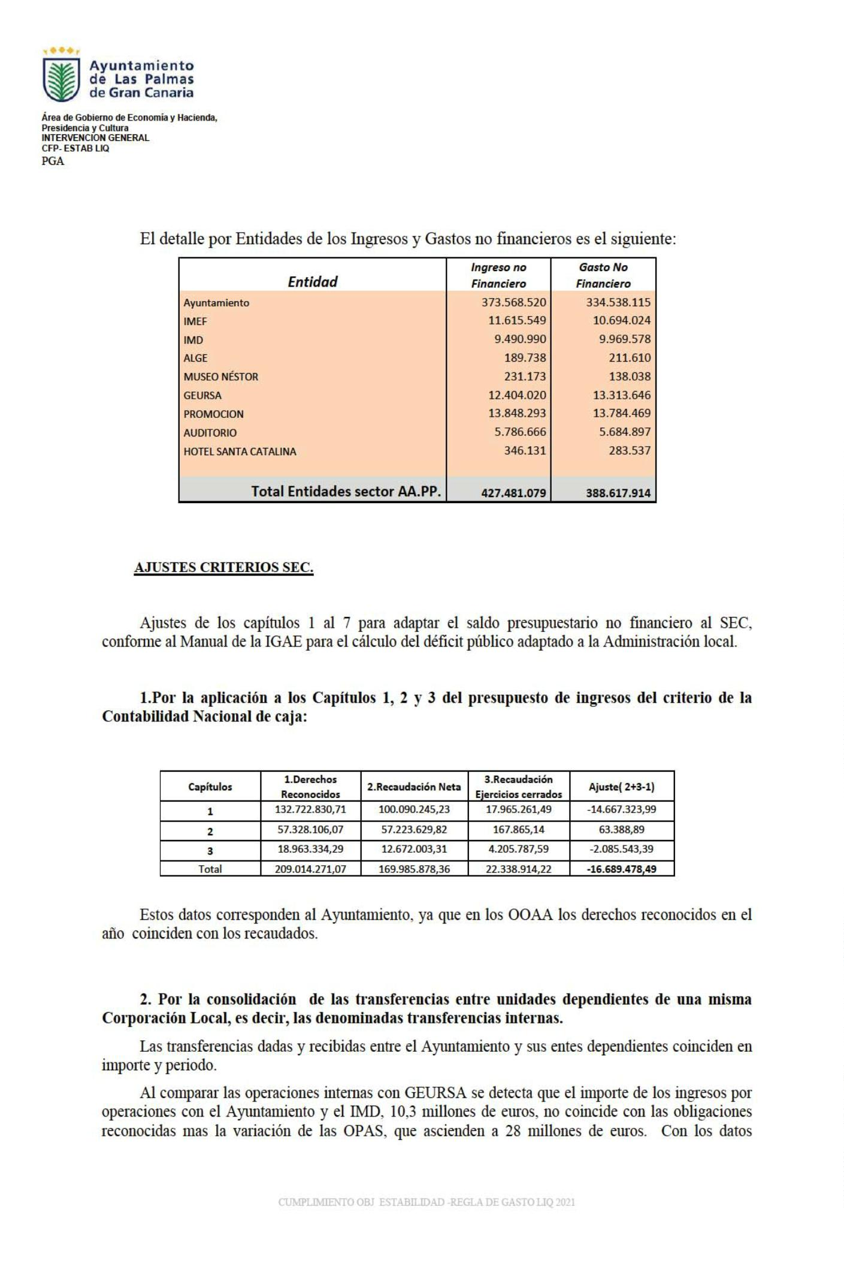

187

ꢀꢀ



ꢀ

ꢀꢀ

ÈUHDꢀGHꢀ\*RELHUQRꢀGHꢀ(FRQRPtDꢀ\ꢀ+DFLHQGDꢁꢀ3UHVLGHQFLDꢀ\ꢀ&XOWXUDꢀꢀ

,17(59(1&,21ꢀ\*(1(5$/ꢀ&)3ꢂꢀ(67$%ꢀ/,4ꢀ

3\*$ꢀꢀ

ꢀ

DSRUWDGRVꢀSRUꢀODꢀVRFLHGDGꢅꢀQRꢀHVꢀSRVLEOHꢀLGHQWLILFDUꢀODVꢀGLIHUHQFLDVꢅꢀ\ꢀSRUꢀSUXGHQFLDꢅꢀQLꢀUHDOL]DUꢀDMXVWHꢀDOJXQRꢈꢀ

(Qꢀ UHODFLyQꢀ Dꢀ ODꢀ )XQGDFLyQꢀ $XGLWRULRꢅꢀ VHꢀ KDFHꢀ XQꢀ DMXVWHꢀ SRUꢀ LQJUHVRVꢀ QRꢀ LPSXWDGRVꢀ Dꢀ ODꢀFRQWDELOLGDGꢀGHꢀODꢀIXQGDFLyQꢀHQꢀꢁꢃꢁꢄꢀSRUꢀLPSRUWHꢀGHꢀꢁꢃꢉꢈꢑꢄꢁꢀHXURVꢈꢀ

ꢇꢃꢀ 3RUꢀ ODꢀ DSOLFDFLyQꢀ Dꢀ ꢀ ORVꢀ LQWHUHVHVꢀ \ꢀ ODVꢀ GLIHUHQFLDVꢀ GHꢀ FDPELRꢀ GHOꢀ &DStWXORꢀ ꢀ ꢇꢀ GHOꢀSUHVXSXHVWRꢀGHꢀJDVWRVꢀGHOꢀFULWHULRꢀGHꢀODꢀ&RQWDELOLGDGꢀ1DFLRQDOꢀGHꢀGHYHQJRꢃꢀ

1RꢀVHꢀUHDOL]DꢀQLQJ~QꢀDMXVWHꢀSRUꢀHVWHꢀFRQFHSWRꢀHQꢀHVWHꢀDSDUWDGRꢀSRUꢀQRꢀGLVSRQHUꢀGHꢀLQIRUPDFLyQꢈꢀ

ꢀ

ꢈꢃꢀ\*DVWRVꢀUHDOL]DGRꢀHQꢀHOꢀHMHUFLFLRꢀ\ꢀSHQGLHQWHVꢀGHꢀDSOLFDUꢀDOꢀSUHVXSXHVWRꢃꢀ

/DꢀDSOLFDFLyQꢀGHOꢀSULQFLSLRꢀGHꢀGHYHQJRꢀGHOꢀ6LVWHPDꢀ(XURSHRꢀGHꢀ&XHQWDVꢀLPSOLFDꢀODꢀLPSXWDFLyQꢀGHꢀFXDOTXLHUꢀJDVWRꢀHIHFWLYDPHQWHꢀUHDOL]DGRꢀFRQꢀLQGHSHQGHQFLDꢀGHOꢀPRPHQWRꢀHQꢀTXHꢀVHꢀGHFLGDꢀVXꢀLPSXWDFLyQꢀSUHVXSXHVWDULDꢈꢀ 3RUꢀ WDQWRꢅꢀ ODVꢀ FDQWLGDGHVꢀ DERQDGDVꢀ HQꢀ HOꢀ HMHUFLFLRꢀ HQꢀ ODꢀ FXHQWDꢀ ꢉꢄꢊꢀ ³DFUHHGRUHVꢀ SRUꢀ RSHUDFLRQHVꢀ GHYHQJDGDV´ꢀ GDUiQꢀ OXJDUꢀ Dꢀ DMXVWHVꢀ GHꢀ PD\RUHVꢀ HPSOHRVꢀ QRꢀ ILQDQFLHURVꢀ PLHQWUDVꢀ TXHꢀ ODVꢀ FDQWLGDGHVꢀDERQDGDVꢀFRQꢀVLJQRꢀQHJDWLYRꢅꢀHVꢀGHFLUꢀDSOLFDGDVꢀDꢀSUHVXSXHVWRꢅꢀLPSOLFDUiQꢀDMXVWHVꢀGHꢀPHQRUHVꢀHPSOHRVꢀQRꢀILQDQFLHURVꢈꢀ(VWHꢀDMXVWHꢀVHꢀSXHGHꢀFDOFXODUꢀFRPRꢀODꢀGLIHUHQFLDꢀHQWUHꢀVDOGRꢀLQLFLDOꢀ\ꢀILQDOꢀGHꢀODꢀFXHQWDꢀꢉꢄꢊꢅꢀGHꢀIRUPDꢀTXHꢀVLꢀHOꢀVDOGRꢀILQDOꢀHVꢀVXSHULRUꢀDOꢀLQLFLDOꢅꢀGLVPLQXLUiꢀHOꢀVXSHUiYLWꢅꢀ\ꢀORꢀFRQWUDULRꢅꢀ DXPHQWDUtDꢀHOꢀVXSHUiYLWꢈꢀ

(VWDꢀ ,QWHUYHQFLyQꢀ \*HQHUDOꢀ HQꢀ ORVꢀ LQIRUPHVꢀ GHꢀ HMHUFLFLRVꢀ DQWHULRUHVꢀ KDFtDꢀ XQꢀ DQiOLVLVꢀ GHꢀ ODVꢀ RSHUDFLRQHVꢀꢀLQFOXLGDVꢀHQꢀHVWDꢀFXHQWDꢅꢀUHDOL]DEDꢀDMXVWHVꢀFRQꢀREVHUYDFLRQHVꢀSDUDꢀVXꢀUHYLVLyQꢀSRUꢀHOꢀ2\*()ꢅꢀTXHꢀHVWHꢀQRꢀFRQVLGHUDEDꢈꢀ/DꢀUHYLVLyQꢀGHꢀODꢀFXHQWDꢀꢉꢄꢊꢀHVꢀPX\ꢀODERULRVDꢅꢀGDGRꢀORꢀOLPLWDGRꢀGHꢀORVꢀPHGLRVꢀKXPDQRVꢀ\ꢀWpFQLFRVꢀHQꢀODꢀ,QWHUYHQFLyQꢀ\*HQHUDOꢀ\ꢀTXHꢀODVꢀUHJODVꢀILVFDOHVꢀHVWiQꢀVXVSHQGLGDVꢅꢀHQꢀHOꢀSUHVHQWHꢀLQIRUPHꢀQRꢀVHꢀDQDOL]DQꢀODVꢀRSHUDFLRQHVꢀGHꢀODꢀFXHQWDꢀꢉꢄꢊꢈꢀ

(Oꢀ~QLFRꢀDMXVWHꢀTXHꢀVHꢀUHDOL]DꢀꢀHVꢀHOꢀUHODWLYRꢀDꢀODꢀDQXODFLyQꢀGHꢀODVꢀ23$6ꢀUHODWLYDVꢀDOꢀMXVWLSUHFLRꢀGHꢀꢀ ODVꢀSDUFHODVꢀ&,&(5ꢀUHVHxDGDVꢀHQꢀDQWHULRUHVꢀLQIRUPHVꢅꢀ\ꢀFX\DVꢀREOLJDFLRQHVꢀIXHURQꢀUHFRQRFLGDVꢀꢀHQꢀHOꢀDxRꢀꢁꢃꢁꢃꢅꢀDQXOiQGRVHꢀODVꢀ23$6ꢀDVRFLDGDVꢀHQꢀHOꢀꢁꢃꢁꢄꢀSRUꢀLPSRUWHꢀꢆꢈꢎꢃꢇꢈꢑꢉꢉꢅꢁꢁꢀꢈꢀ

(OꢀDMXVWHꢀꢀDꢀUHDOL]DUꢀVHUtDꢀHOꢀVLJXLHQWHꢀꢋGDWRVꢀDꢀODꢀIHFKDꢀGHꢀHPLVLyQꢀGHOꢀSUHVHQWHꢀLQIRUPHꢌꢐꢀ

ꢀ &XHQWDꢀꢉꢄꢊ

ꢀ $\XQWDPLHQWR ,0' ,0() $/\*(ꢀ 0XVHR

6DOGRꢀFRQWDEOHꢀLQLFLDOꢀ ꢀ

DMXVWDGRꢀ ꢆꢃꢈꢃꢍꢇꢈꢃꢍꢇꢅꢎꢊ ꢊꢃꢑꢈꢍꢃꢁꢅꢊꢃ ꢊꢉꢃꢈꢑꢃꢃꢅꢍꢁ ꢉꢈꢉꢊꢄꢅꢁꢑꢀ 6DOGRꢀFRQWDEOHꢀILQDOꢀ

SURYLVLRQDOꢀ ꢎꢉꢈꢉꢍꢑꢈꢎꢆꢇꢅꢇꢃ ꢊꢉꢆꢈꢃꢎꢇꢅꢄꢃ ꢁꢄꢍꢈꢎꢆꢇꢅꢁꢉ ꢄꢄꢈꢁꢇꢉꢅꢉꢃꢀ ꢀ

6LQꢀ

$MXVWHꢀ

ꢏꢄꢉꢈꢉꢃꢊꢈꢎꢄꢑꢅꢆꢆ ꢏꢊꢆꢈꢍꢎꢊꢅꢎꢃ ꢄꢁꢍꢈꢃꢁꢉꢅꢁꢎ ꢏꢇꢈꢎꢊꢊꢅꢄꢄꢀ GDWRV ꢁ

/Dꢀ2UGHQꢀ+$&ꢂꢄꢊꢇꢉꢂꢁꢃꢄꢎꢅꢀGHꢀꢄꢁꢀGHꢀGLFLHPEUHꢅꢀSRUꢀODꢀTXHꢀVHꢀPRGLILFDQꢀORVꢀSODQHVꢀGHꢀFXHQWDVꢀ ORFDOHVꢀDQH[RVꢀDꢀODVꢀLQVWUXFFLRQHVꢀGHꢀORVꢀPRGHORVꢀQRUPDOꢀ\ꢀVLPSOLILFDGRꢀGHꢀFRQWDELOLGDGꢀORFDOꢅꢀDSUREDGDVꢀSRUꢀODVꢀÏUGHQHVꢀ+$3ꢂꢄꢆꢎꢄꢀ\ꢀꢄꢆꢎꢁꢂꢁꢃꢄꢊꢅꢀGHꢀꢁꢃꢀGHꢀVHSWLHPEUHꢅꢀUHGHILQHꢀODꢀFXHQWDꢀꢉꢄꢊꢀ\ꢀVXꢀXWLOL]DFLyQꢀSDVDꢀGHꢀVHUꢀDQXDOꢀDꢀWULPHVWUDOꢅꢀFRPRꢀPtQLPRꢈꢀ

(VꢀQHFHVDULRꢀTXHꢀSRUꢀSDUWHꢀGHOꢀÏUJDQRꢀGHꢀ\*HVWLyQꢀ(FRQyPLFRꢀꢏ)LQDQFLHUDꢀUHJLVWUHꢀODVꢀRSHUDFLRQHVꢀꢀWULPHVWUDOPHQWHꢀ ꢅꢀ DGHPiVꢅꢀ GHꢀ DGRSWDUꢀ PHGLGDVꢀ GHꢀ FRQWUROꢀ \ꢀ VHJXLPLHQWRꢀ GHꢀ ODVꢀ RSHUDFLRQHVꢀ TXHꢀ VHꢀUHJLVWUDQꢀHQꢀHVDꢀFXHQWDꢀꢉꢄꢊꢅꢀGHELHQGRꢀVHUꢀORVꢀFHQWURVꢀJHVWRUHVꢀPiVꢀGLOLJHQWHVꢀHQꢀODꢀFRPXQLFDFLyQꢀGHꢀODꢀLQIRUPDFLyQꢈꢀ'HEHUtDꢀSURFHGHUVHꢀDꢀODꢀUHYLVLyQꢀFRPSOHWDꢀGHꢀODVꢀDQRWDFLRQHVꢀHQꢀGLFKDꢀFXHQWDꢈꢀ

&803/,0,(172ꢀ2%- ꢀ(67$%,/,'$'ꢀꢏ5(\*/$ꢀ'(ꢀ\*$672ꢀ/,4ꢀꢁꢃꢁꢄꢀ

188

ꢀꢀ



ꢀ

ꢀꢀ

ÈUHDꢀGHꢀ\*RELHUQRꢀGHꢀ(FRQRPtDꢀ\ꢀ+DFLHQGDꢁꢀ3UHVLGHQFLDꢀ\ꢀ&XOWXUDꢀꢀ

,17(59(1&,21ꢀ\*(1(5$/ꢀ&)3ꢂꢀ(67$%ꢀ/,4ꢀ

3\*$ꢀꢀ

ꢀ

ꢉꢃꢀ'HYROXFLRQHVꢀSHQGLHQWHVꢀGHꢀSDJRꢃꢀ

(Oꢀ VDOGRꢀ ꢀ ꢀ GHꢀ ODꢀ FXHQWDꢀ FRQWDEOHꢀ ꢉꢄꢎꢀ ³$FUHHGRUHVꢀ SRUꢀ GHYROXFLyQꢀ GHꢀ LQJUHVRV´ꢀ ꢀ DVFLHQGHꢀ DꢀꢊꢈꢉꢍꢑꢈꢄꢊꢎꢅꢎꢆꢀHXURVꢈꢀ(OꢀVDOGRꢀLQLFLDOꢀGHꢀGLFKDꢀFXHQWDꢀIXHꢀꢀꢊꢆꢁꢈꢑꢉꢑꢅꢊꢉꢀHXURVꢈꢀ(OꢀDMXVWHꢀDꢀUHDOL]DUꢀVHUtDꢀODꢀ GLIHUHQFLDꢀ HQWUHꢀ GLFKRVꢀ VDOGRVꢅꢀ DOꢀ VHUꢀ HOꢀ VDOGRꢀ ILQDOꢀ VXSHULRUꢀ ꢀ DOꢀ LQLFLDOꢅꢀ GLVPLQX\Hꢀ HOꢀ VXSHUiYLWꢀ HQꢀ ꢊꢈꢃꢎꢇꢈꢄꢎꢑꢅꢍꢊꢀHXURVꢀꢈꢀ

ꢊꢃꢀꢀ$MXVWHVꢀSRUꢀODVꢀOLTXLGDFLRQHVꢀQHJDWLYDVꢀHQꢀODꢀ3DUWLFLSDFLyQꢀHQꢀORVꢀ7ULEXWRVꢀGHOꢀ(VWDGRꢀGHꢀDxRꢀꢂꢋꢋꢌꢀ\ꢀꢀꢂꢋꢋꢍꢃꢀ

3RUꢀODꢀGHYROXFLyQꢀHQꢀHOꢀDxRꢀꢁꢃꢁꢄꢀGHꢀODVꢀOLTXLGDFLRQHVꢀQHJDWLYDVꢀGHꢀHMHUFLFLRVꢀDQWHULRUHVꢀHOꢀDMXVWHꢀWRWDOꢀDꢀUHDOL]DUꢀVHUtDꢀGHꢀꢄꢈꢊꢊꢇꢈꢊꢉꢍꢅꢑꢁꢀHXURVꢅꢀDXPHQWDQGRꢀODꢀFDSDFLGDGꢀGHꢀILQDQFLDFLyQꢈꢀ

ꢌꢃꢀ,QJUHVRVꢀREWHQLGRVꢀGHOꢀ3UHVXSXHVWRꢀGHꢀODꢀ8QLyQꢀ(XURSHDꢀ

ꢀ/DꢀJHVWLyQꢀGHVFHQWUDOL]DGDꢀGHꢀORVꢀIRQGRVꢀHXURSHRVꢀLPSOLFDꢀTXHꢀꢀHOꢀPRPHQWRꢀGHꢀUHFRQRFLPLHQWRꢀGHꢀORVꢀIRQGRVꢀHQꢀFRQWDELOLGDGꢀQDFLRQDOꢀꢀGHEDꢀFRLQFLGLUꢀFRQꢀHOꢀGHꢀODꢀUHPLVLyQꢀSRUꢀODꢀ&RUSRUDFLyQꢀ/RFDOꢀGHꢀODꢀ GRFXPHQWDFLyQꢀGHOꢀJDVWRꢀUHDOL]DGRꢀDꢀODVꢀ8QLGDGHVꢀ$GPLQLVWUDGRUDVꢈꢀꢀ

&RQꢀ LQGHSHQGHQFLDꢀ GHOꢀ FULWHULRꢀ SUHVXSXHVWDULRꢀ GHꢀ FRQWDELOL]DFLyQꢀ DSOLFDGRꢀ SRUꢀ ODꢀ &RUSRUDFLyQꢀ /RFDOꢀSDUDꢀHOꢀUHJLVWURꢀGHꢀODVꢀWUDQVIHUHQFLDVꢀFRPXQLWDULDVꢅꢀHOꢀDMXVWHꢀDꢀUHDOL]DUꢀSDUDꢀHOꢀFiOFXORꢀGHOꢀGpILFLWꢀHQꢀ FRQWDELOLGDGꢀ QDFLRQDOꢀ YHQGUiꢀ GHWHUPLQDGRꢀ SRUꢀ ODꢀ GLIHUHQFLDꢀ HQWUHꢀ ORVꢀ GHUHFKRVꢀ UHFRQRFLGRVꢀ SRUꢀ ORVꢀ IRQGRVꢀ HXURSHRVꢀ HQꢀ ODꢀ OLTXLGDFLyQꢀ SUHVXSXHVWDULDꢀ \ꢀ HOꢀ LPSRUWHꢀ UHVXOWDQWHꢀ GHꢀ DSOLFDUꢀ HOꢀ SRUFHQWDMHꢀ GHꢀFRILQDQFLDFLyQꢀTXHꢀFRUUHVSRQGDꢀDOꢀJDVWRꢀFHUWLILFDGRꢀ\ꢀUHPLWLGRꢀDꢀODꢀ8QLGDGꢀ$GPLQLVWUDGRUDꢈꢀꢀ

(QꢀHOꢀHMHUFLFLRꢀꢁꢃꢁꢄꢅꢀORVꢀGHUHFKRVꢀUHFRQRFLGRVꢀSRUꢀIRQGRVꢀ('86,ꢀDVFLHQGHQꢀDꢀꢉꢑꢊꢈꢃꢁꢁꢅꢆꢍꢅꢀVLHQGRꢀ ODVꢀ REOLJDFLRQHVꢀ UHFRQRFLGDVꢀ ꢉꢃꢄꢈꢇꢄꢄꢅꢄꢊꢅꢀ HOꢀ SRUFHQWDMHꢀ GHꢀ ILQDQFLDFLyQꢀ HVꢀ GHOꢀ ꢎꢍꢒꢈꢀ $ꢀ HIHFWRVꢀ GHOꢀSUHVHQWHꢀLQIRUPHꢅꢀVHꢀSUHVXSRQHꢀTXHꢀODVꢀREOLJDFLRQHVꢀUHFRQRFLGDVꢀKDQꢀVLGRꢀFHUWLILFDGDVꢈꢀ

6LꢀHOꢀLPSRUWHꢀGHꢀORVꢀGHUHFKRVꢀUHFRQRFLGRVꢀVXSHUDꢀHOꢀYDORUꢀTXHꢀVHꢀSUHYpꢀYDꢀDꢀVHUꢀUHHPEROVDGRꢀSRUꢀODꢀ8(ꢅꢀVHꢀSUDFWLFDUiꢀXQꢀDMXVWHꢀQHJDWLYRꢀDOꢀVDOGRꢀSUHVXSXHVWDULRꢅꢀDXPHQWDQGRꢀHOꢀGpILFLWꢀꢅꢀHQꢀHVWHꢀFDVRꢅꢀHQꢀꢄꢍꢄꢈꢇꢍꢊꢅꢁꢑꢀHXURVꢈꢀ

ꢍꢃꢀꢀ$SRUWDFLRQHVꢀGHꢀFDSLWDOꢀDꢀHPSUHVDVꢀS~EOLFDVꢀꢃꢀ

(QꢀHOꢀHMHUFLFLRꢀꢁꢃꢁꢄꢀQRꢀVHꢀKDQꢀUHDOL]DGRꢀQXHYDVꢀDSRUWDFLRQHVꢈꢀ

ꢄꢋꢃꢀ2WURVꢀDMXVWHVꢀ

(QꢀHOꢀHMHUFLFLRꢀꢁꢃꢁꢄꢀQRꢀVHꢀGLVSRQHꢀGHꢀLQIRUPDFLyQꢀSDUDꢀUHDOL]DUꢀRWURVꢀDMXVWHVꢈꢀ

ꢀ

ꢀ

ꢀ

ꢀ

ꢀ

&803/,0,(172ꢀ2%- ꢀ(67$%,/,'$'ꢀꢏ5(\*/$ꢀ'(ꢀ\*$672ꢀ/,4ꢀꢁꢃꢁꢄꢀ

189

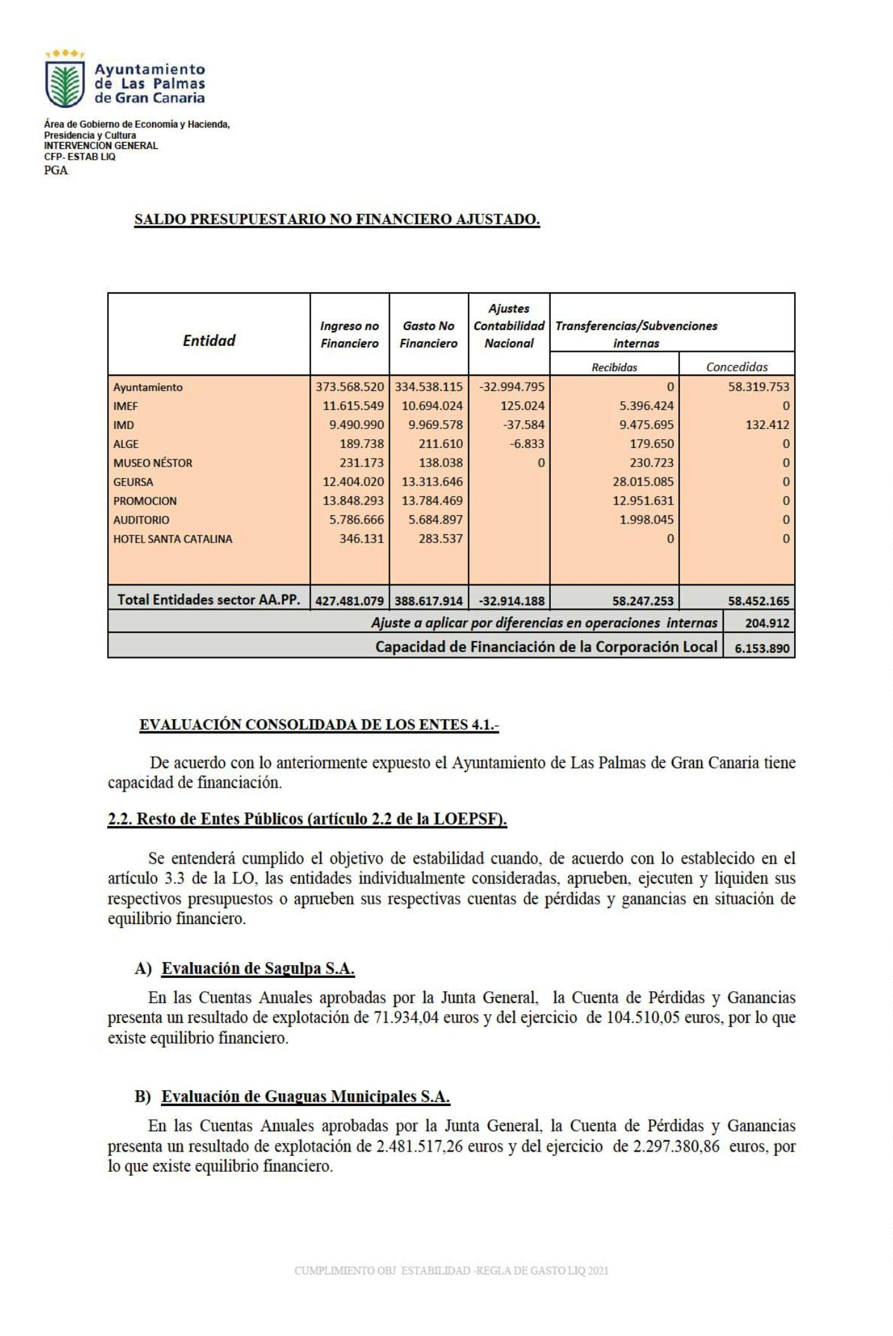

190

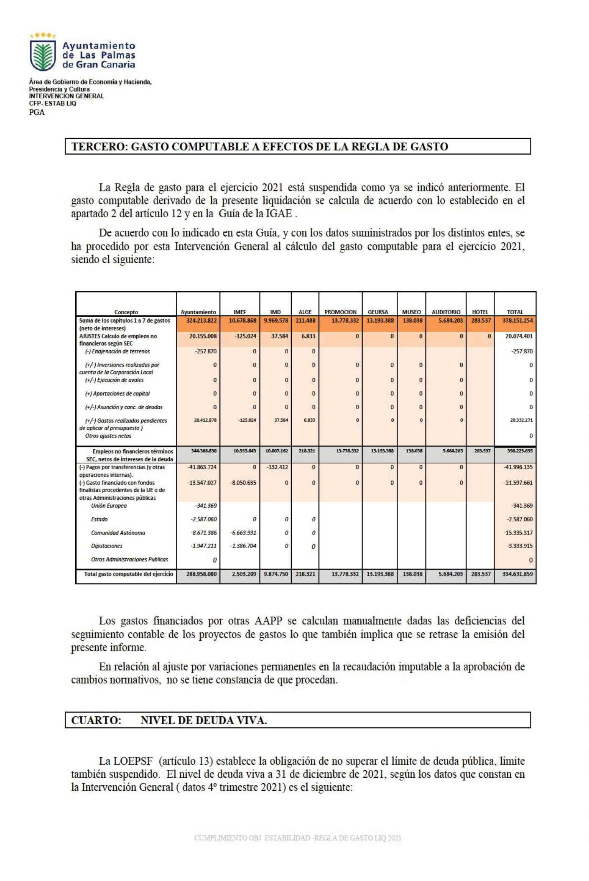

191

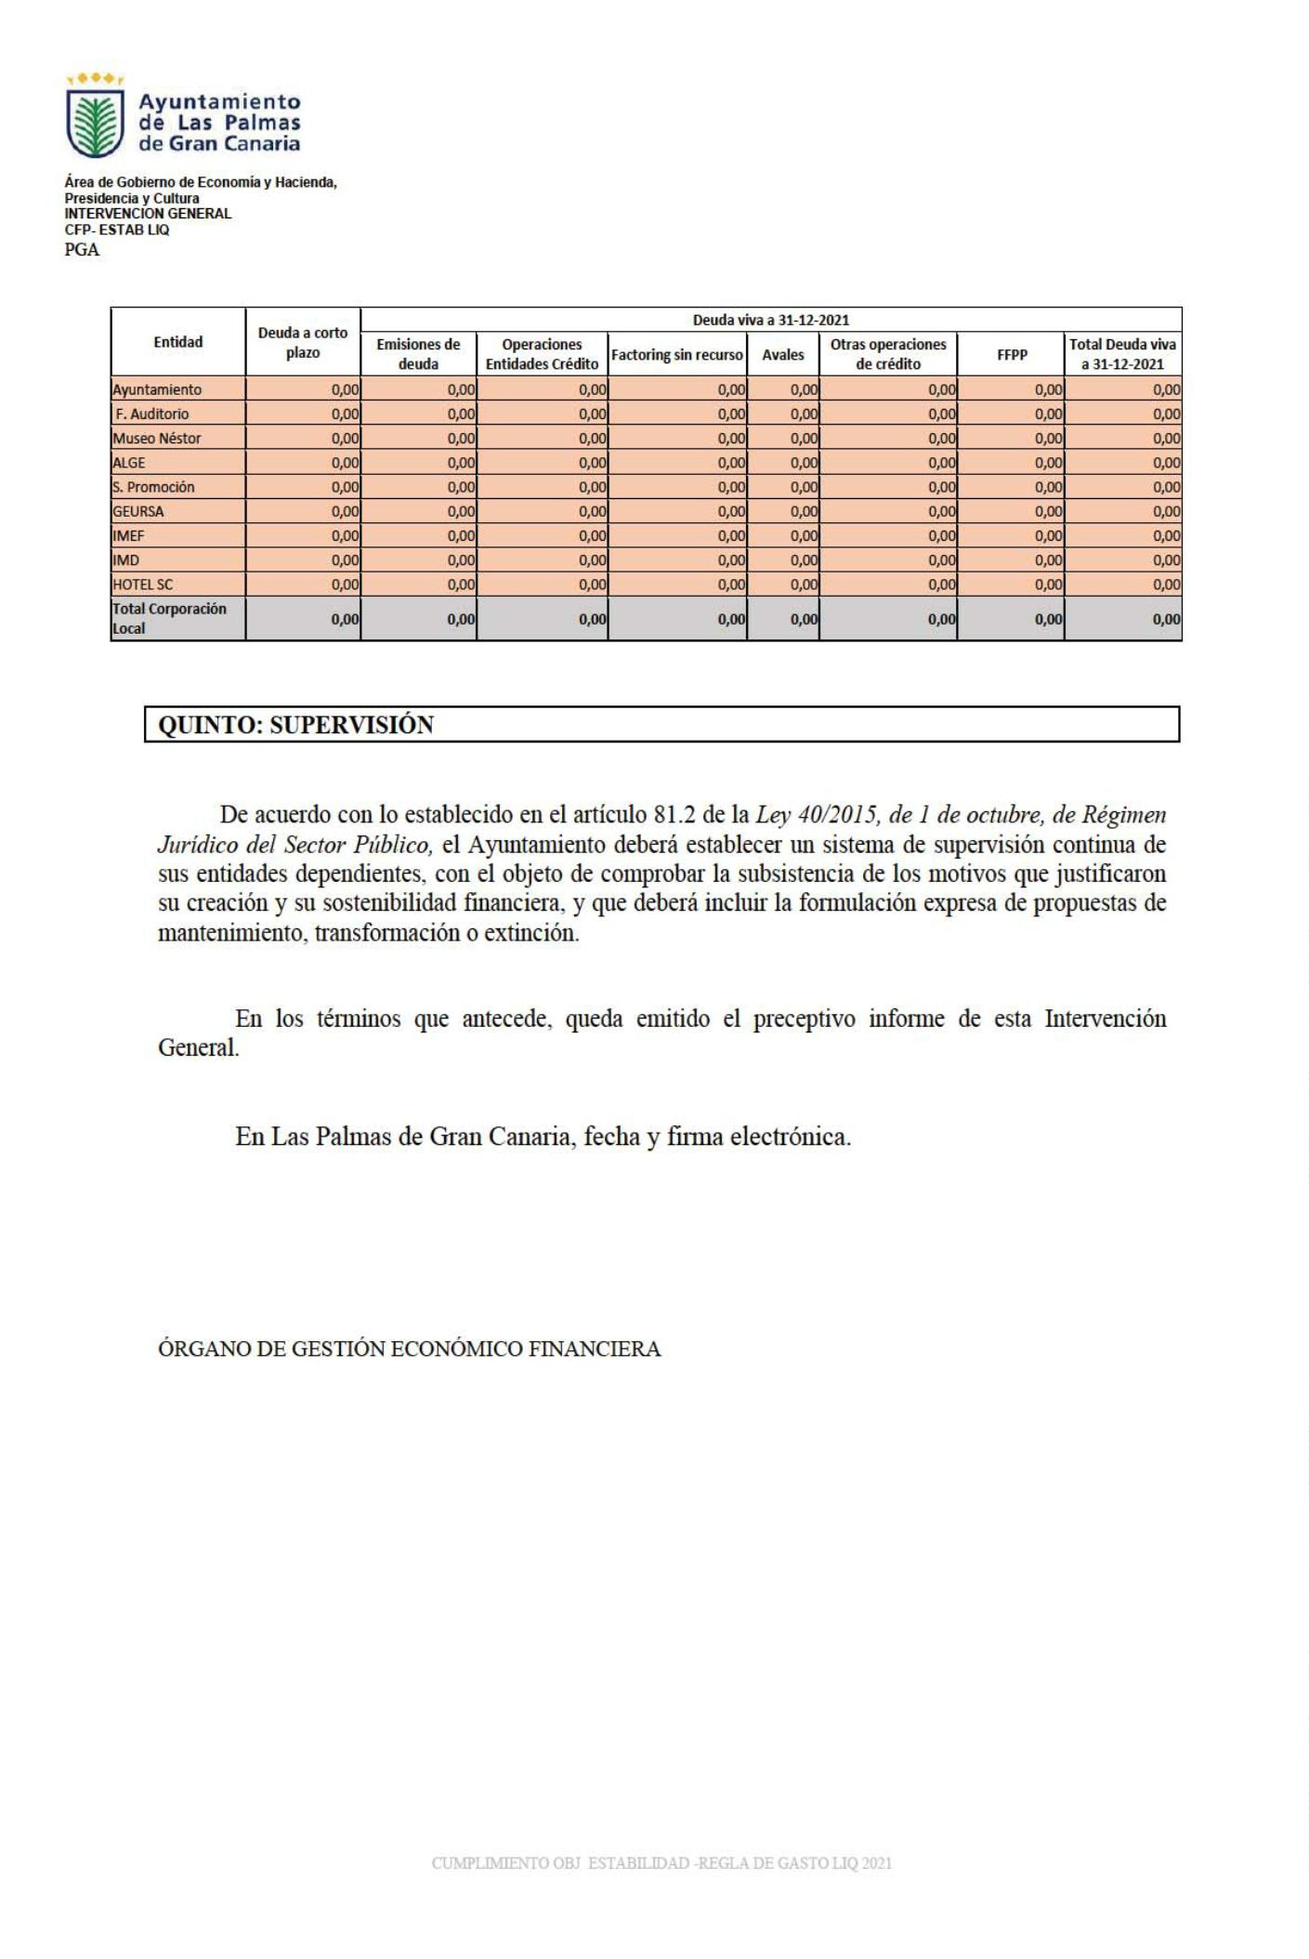

192